Inland Seas Educational Association (ISEA)
Great Lakes - Family Discovery Sail Programs
Hessel Harbor Marina
July 11 & 12, 2016

Tickets go on sale May 10
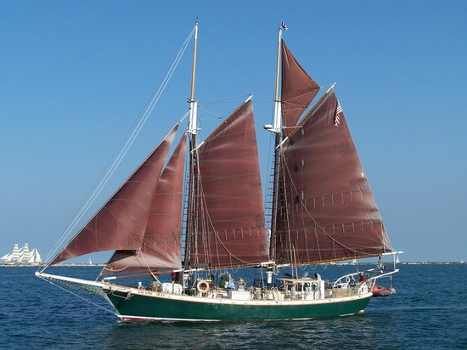

77 foot “tall ship” schooner Inland Seas

Family Discover Sail programs are open to the public – local family groups including children are encouraged. The adventure begins as we leave the docks. You will help trained instructors trawl for fish, collect bottom, plankton & water samples, raise the anchor & sails and take a turn at the helm. While under sail small groups will rotate thru stations to study the collected samples and discuss how they relate to the health of the Great Lakes.

- There will be two (3 hour) sails per day; each limited to 32 participants for $10 per person. For ISEA Family Discovery Sail program descriptions and information go to schoolship.org
For ticket purchase go to - schoolship.org
    - Buy Tickets (click)
      - Scroll down to Specialty Events
        - Select Family Discovery Sail – Hessel
          - Info & Tickets (Click and follow links)

Sponsored by: Les Cheneaux Watershed Council, Co-Sponsor: Les Cheneaux Lions Club

